
MILA ACTIVITY
CSA0506-DBMS
PRESENTED BY:
AAMEENA I(192511284)
BAVANI SRI M(192311405)
R GOPI CHANDANA(192320030)
TITLE: PERSONAL EXPENSE TRACKER
INTRODUCTION:
The Personal Expense Tracker is a database system used to record and manage a user's daily expenses. It helps users store expense details, organize expenses into categories, and set budgets. The ER diagram represents the entities, attributes, primary keys, foreign keys, and relationships in the system.
ENTITIES:
The ER diagram contains four main entities:
1. USER
- User_ID – Primary Key
- Name
- Email
- Password
The USER entity stores the details of the person using the expense tracker.
2. EXPENSE
- Expense_ID – Primary Key
- User_ID – Foreign Key
- Category_ID – Foreign Key
- Amount
- Date
- Description
The EXPENSE entity stores individual expense transactions made by users.
3. CATEGORY
- Category_ID – Primary Key
- Category_Name
The CATEGORY entity is used to classify expenses, such as Food, Travel, Shopping, Bills, and Education.
4. BUDGET
- Budget_ID – Primary Key
- User_ID – Foreign Key
- Category_ID – Foreign Key
- Amount
- Month
The BUDGET entity stores the spending limit set by a user for a particular category and month.
RELATIONSHIPS:
USER – EXPENSE: MAKES
- A user can make many expenses.
- Each expense belongs to one user.
- Therefore, the relationship is 1 : M (one-to-many).
CATEGORY – EXPENSE: BELONGS TO
- One category can contain many expenses.
- Each expense belongs to one category.
- Therefore, the relationship is 1 : M.
USER – BUDGET: SETS
- A user can set many budgets.
- Each budget is associated with one user.
- Therefore, the relationship is 1 : M.
CATEGORY – BUDGET: FOR
- A category can be associated with many budgets.
- Each budget is created for one category.
- Therefore, the relationship is 1 : M.
KEYS:
- Primary Key (PK): Uniquely identifies each record.
  - User_ID
  - Expense_ID
  - Category_ID
  - Budget_ID
- Foreign Key (FK): Connects one entity with another entity.
  - User_ID in EXPENSE
  - Category_ID in EXPENSE
  - User_ID in BUDGET
  - Category_ID in BUDGET
SYMBOLS USED:
- Rectangle → Entity
- Oval → Attribute
- Diamond → Relationship
- Underlined attribute → Primary Key
- FK → Foreign Key
- 1 : M → One-to-many relationship
- 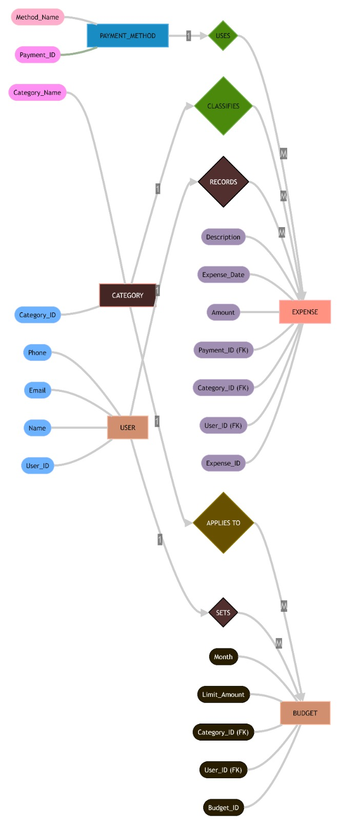

WORKING OF THE SYSTEM:
When a user registers, their information is stored in the USER entity. The user can then add multiple expenses. Each expense contains an amount, date, description, and category. The category helps organize expenses. The user can also create budgets for different categories and months. Using these relationships, the system can track spending and compare expenses with the set budget.
CONCLUSION:
Thus, the ER diagram provides a clear database structure for the Personal Expense Tracker. It avoids unnecessary duplication of data, maintains relationships between users, expenses, categories, and budgets, and provides a strong foundation for implementing the database system efficiently.


